**PRACTICAL 03**

**AIM -**

Learning EXCEL:

A] Introduction to MS Excel files, Workbooks, Worksheets, Columns and Rows.

B] Formatting Worksheets.

**3 [A]:**

**INTRODUCTION -**

Microsoft Excel is used to organize, calculate, analyze, and visualize data in spreadsheets for a variety of purposes, including financial management, data entry and management, project tracking, budgeting, and creating charts and graphs.

**Core Functions -**

* ***Data Organization and Entry:*** Excel creates grids of cells in rows and columns to hold text, numbers, and formulas, allowing users to easily organize and input data.
* ***Calculations and Formulas:*** Users can apply formulas to perform complex mathematical operations, such as sums, averages, and other values from numerical data.
* ***Data Analysis and Visualization:*** Excel provides tools like pivot tables to summarize large datasets and charting tools to create various graphs, bar charts, and histograms to visualize trends and insights.

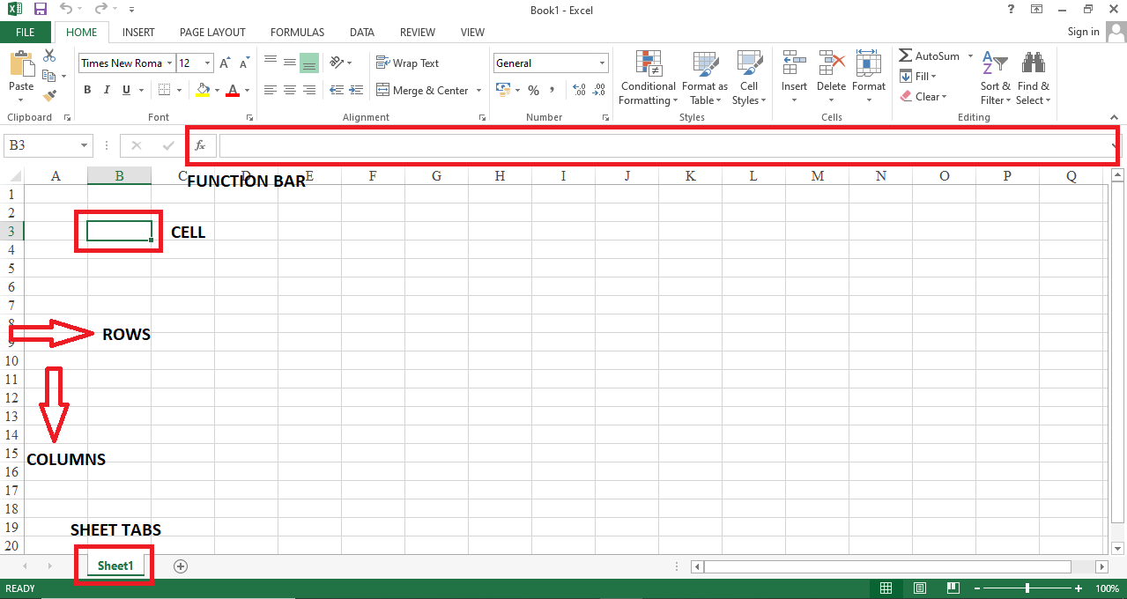

**3 [B] :**

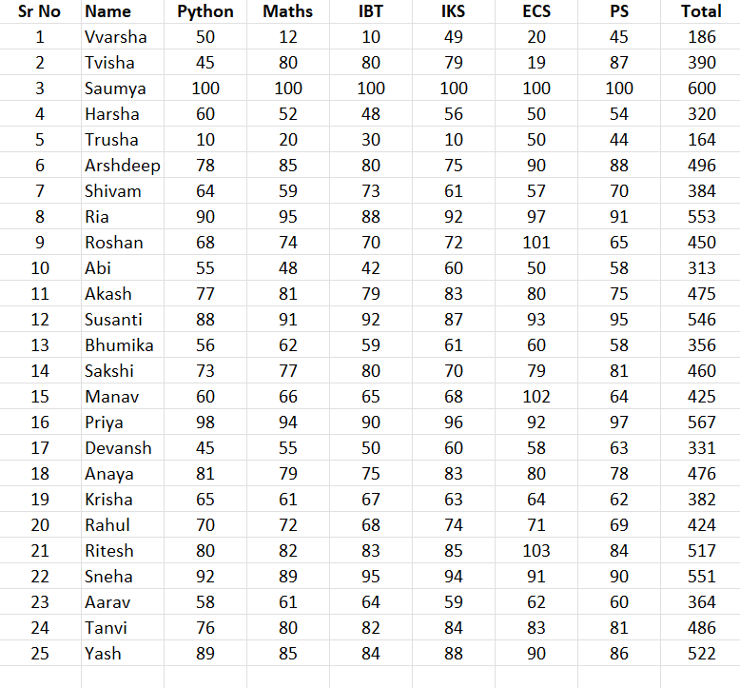

**CONCLUSION -**

Hence, we have successfully completed formatting in excel.